**Use Case UC1: Sign Up**

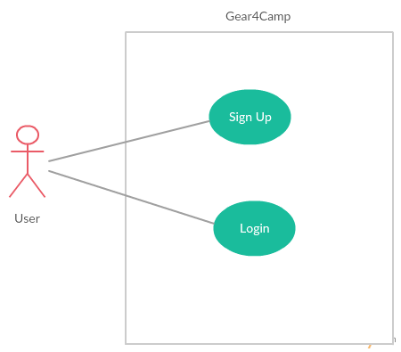

**Scope:** Gear4Camp system

**Level:** User goal

**Actor:** User (Primary)

**Stakeholders and Interests:**

**User:** wants to register in the Gear4Camp Application.

**Preconditions, Success Guarantee:** Must have valid Email ID’s

**Main Success Scenario:**

1. User opens the website.
2. System prompts for a username and password to login or to register a new account.
3. User selects sign up option.
4. System prompts user for registration information, such as name, Email ID, password, contact number.
5. User enters his/her information.
6. System verifies information and creates account for new member.

**Extensions:**

**Alt Flow 1. Invalid Email ID**

1. User enters invalid Email address (i.e. Email already used or isn’t a real Email address).
2. System detects invalid Email address and prompts user to enter a valid Email address.
3. User enters valid Email address and continues registration.

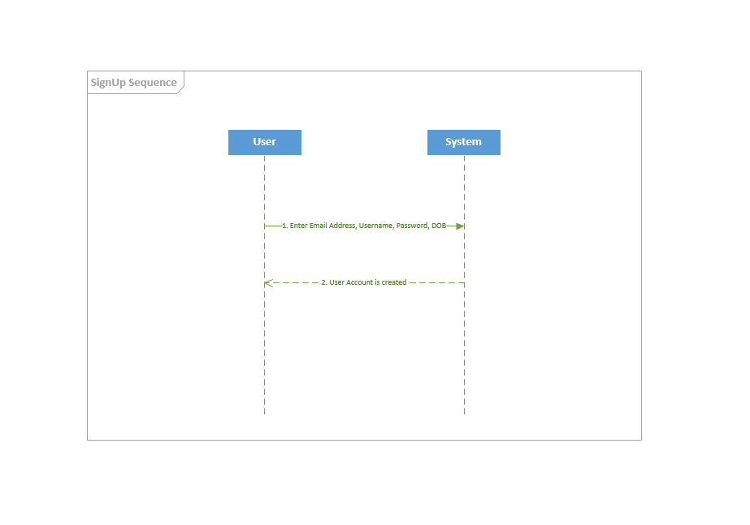

**Use Case UC2: Login**

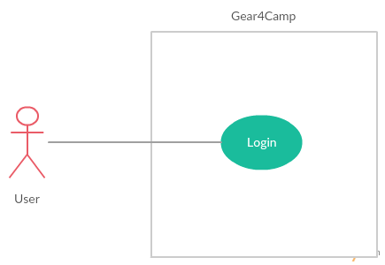

**Scope:** Gear4Camp website

**Level:** User goal

**Primary Actor:** User (Primary)

**Stakeholders and Interests:**

**User**: Wants user-friendly interface.

**Preconditions, Success Guarantee:** User has registered for an account.

**Main Success Scenario:**

1. User opens the Website and is not logged in the system.
2. System requests that the user enter his/her username(Email Id) and password.
3. User enters his/her username and password.
4. System validates the entered username and password and logs the user into the system.

**Alternate Flows:**

**Alt1. Invalid Username / Password**

1. User enters an invalid username and/or password
2. System displays an error message.

**Special Requirements:**

Unique Username

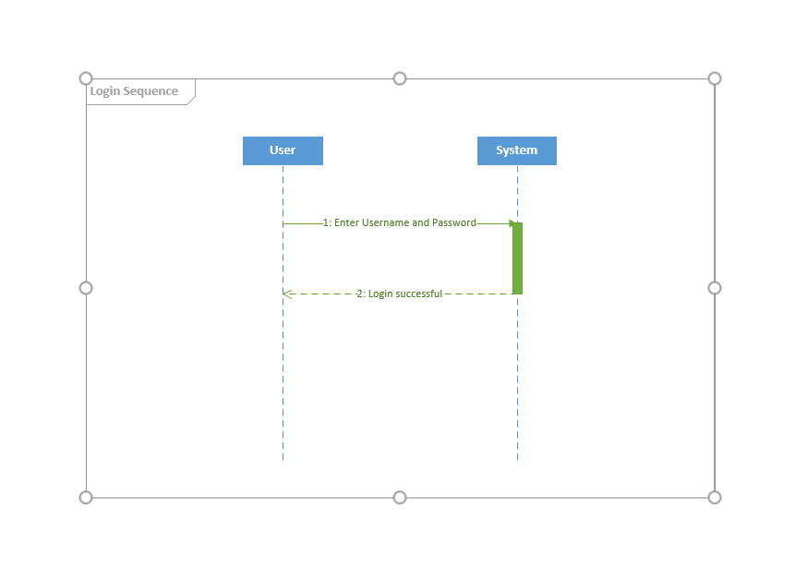

Consolidated Usecase Diagram

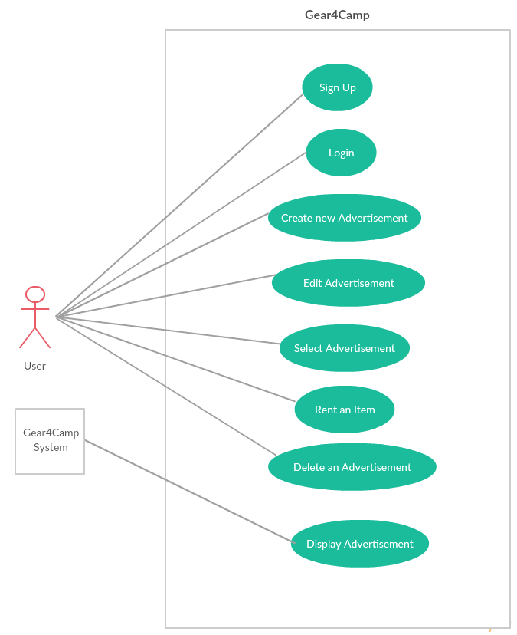

**Use case UC3: Create AD**

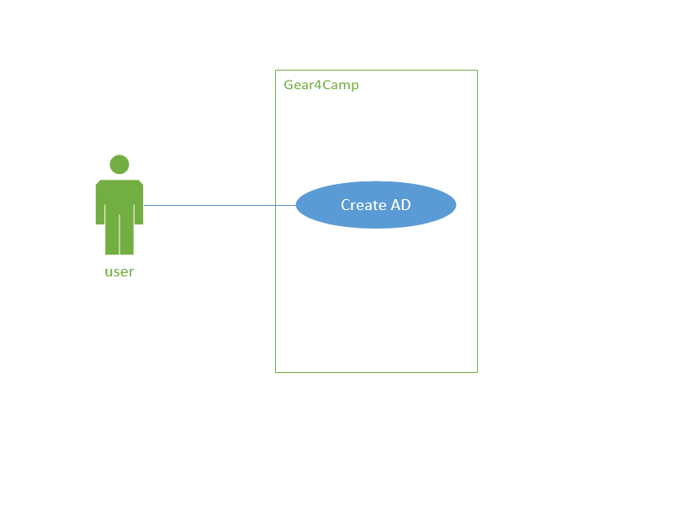

**Scope:** Gear4Camp website

**Level:** User goal

**Primary Actor:** User

**Stakeholders and Interests:**

**User**: wants to post an advertisement on Gear4Camp website.

**Preconditions, Success Guarantee:** User has a valid account and successfully login into the website.

**Main Success Scenario:**

1. User click the create AD button in the web page.
2. System direct user into AD creation page and provide text field and picture upload button for user.
3. User edit AD content in provided area and upload pictures if necessary.
4. System save the AD content into database and post it in the website.

**Extensions:**

**Alternate Flows:**

**Alt1. Create AD without login**

1. User click the create AD button in the web page.
2. System direct user into AD creation page and provide text field and picture upload button for user.
3. User edit AD content in provided area and upload pictures if necessary, as the user is not login, he/she should enter contact information in the provided area.
4. System save the AD content into database and post it in the website.

**Special Requirements:** N/A

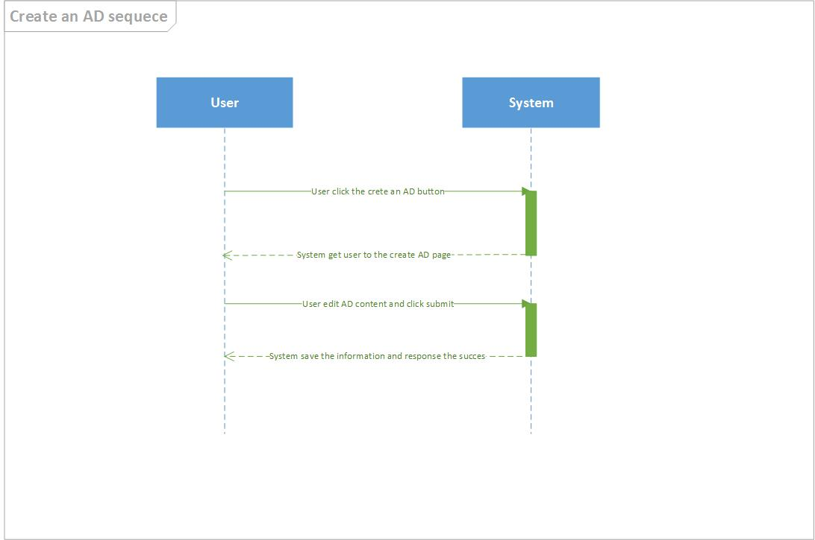

**Use case UC4: Display ADs（In the main page)**

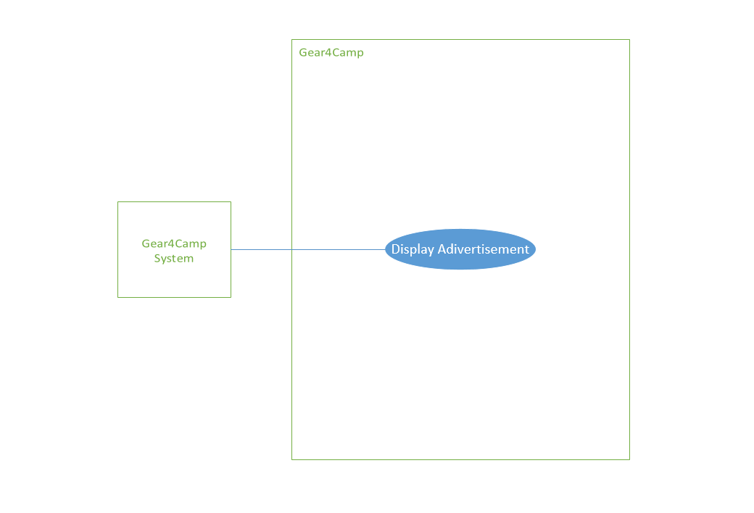

**Scope:** Gear4Camp Website

**Level:** User goal

**Primary Actor:** User

**Stakeholders and Interests:**

**User**: wants to browse some spare item posted in the website which he/ she interested in

**Preconditions, Success Guarantee:** User opens the Gear4Camp website

**Main Success Scenario:**

1. User is the main page of Gear4Camp
2. Server grab the latest ADs and display the key information, including title, item type provide name, location, etc.
3. User click one of the ADs and will be linked to the detailed page.

**Alternate Flows:** N/A

**Special Requirements:**

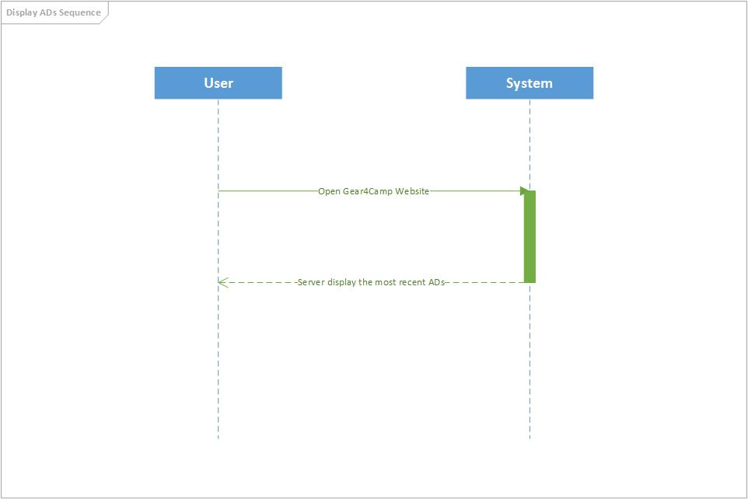

**Use case UC5: Selecting AD**

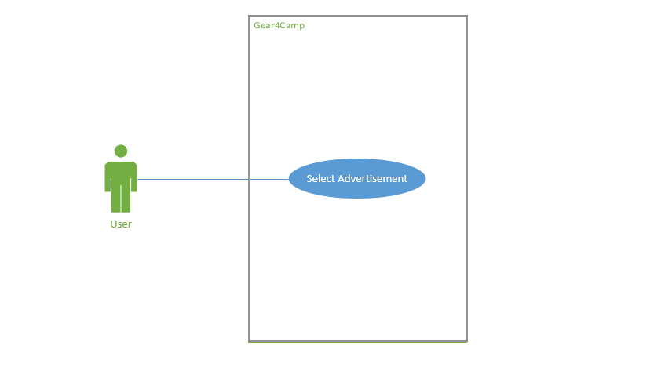

**Scope:** Gear4Camp website

**Level:** User level

**Primary Actor:**  User

**Stakeholders and Interests:**

**User**: wants to view one of the ADs in the website.

**Preconditions, Success Guarantee:** User opens the Gear4Camp website.

**Main Success Scenario:**

1. User clicks one of the ADs displayed in the main page.
2. System direct user into the content page which provide the item information and owner contact information.
3. User contact the owner by the information and complete trading.

**Alternate Flows:** N/A

**Special Requirements:**

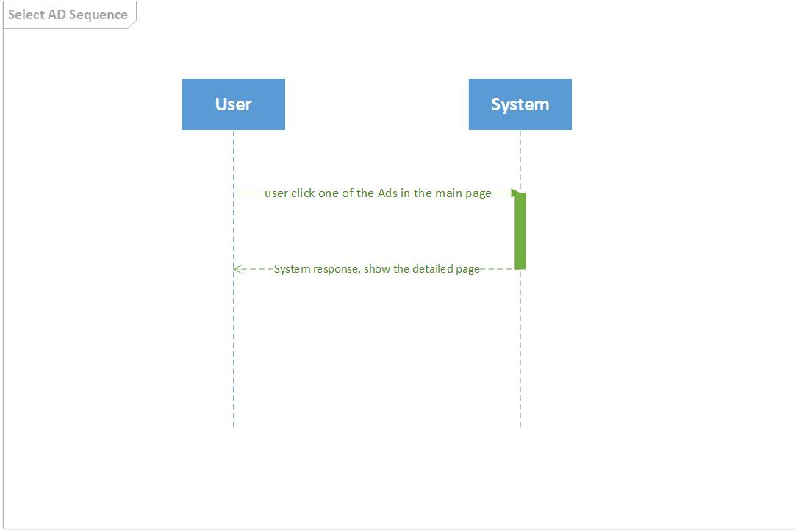

**System Sequence**